**A Comprehensive Analysis of Financial Performance: Insights from a leading Banks**

**INTRODUCTION**

**1.1 OVERVIEW:**

The banking industry world-wide is being transformed. The global forces for change include technologicalinnovation; the deregulation of financial services at the national level and opening-up to international competition; and - equally important - changes in corporate behavior, such as growing disintermediation and increased emphasis on shareholder value. In addition, recent banking crises in Asia and Latin America have accentuated these pressures. The banking industries in central Europe and Latin America have also been transformed as a result of privatizations of state-owned banks that had dominated their banking systems in the past. In this project we are trying to analysis the bank related data and able to extract some insights from the data using Business Intelligence tools. To Extract the Insights from the data and put the data in the form of visualizations, Dashboards and Story we employed Tableau tool.

1.2 **PURPOSE**

The purpose of conducting a comprehensive analysis of financial performance for a leading bank is to evaluate its overall financial health and performance. This involves analyzing various financial metrics and ratios to gain insights into the bank's profitability, efficiency, risk management, and capital adequacy.

**PROBLEM DEFINITION & DESIGN THINKING:**

**Business requirements:**

The business requirements for analyzing the performance and efficiency of banks

in world include identifying KPIs, comparing performance across different

countries and states, identifying patterns and trends over time, identifying

affecting factors, creating interactive dashboards and reports, identifying areas for

improvement, making data-driven decisions, comparing to the industry average

and creating forecasting models for future performance.

**ACTIVITY AND SCREENSHOT**

* Top Banks according to Rank and assest.
* Top Bank according to country based on total assests.
* Top 10 countries with assest proportion.
* Country with total assest using funnel chart in increasing order
* Total assest analysis according to year and quarter
* Top Banks according to total assest

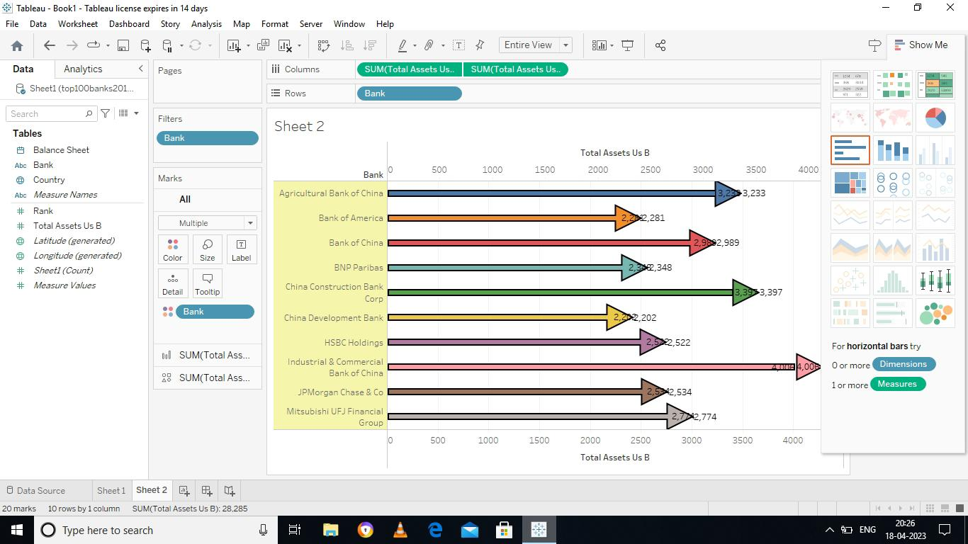

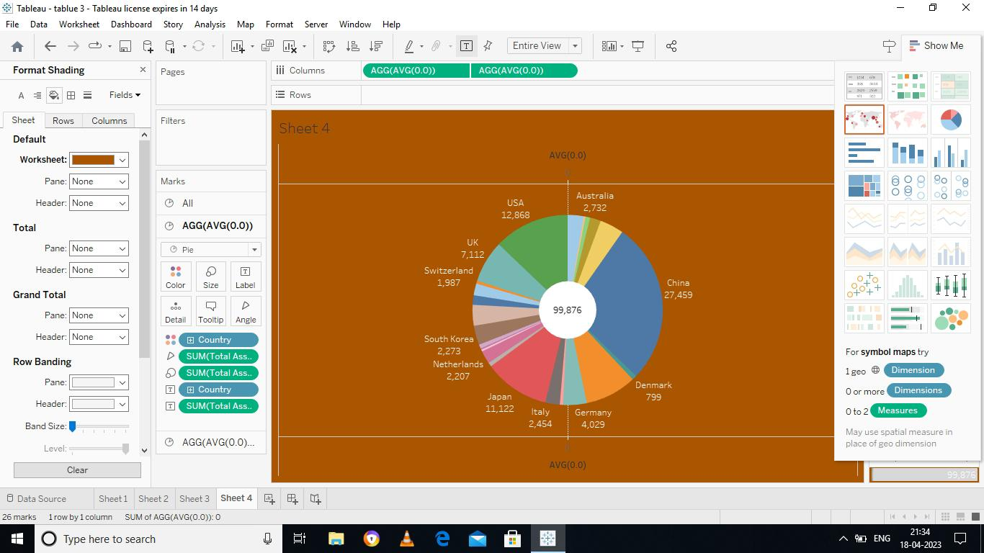

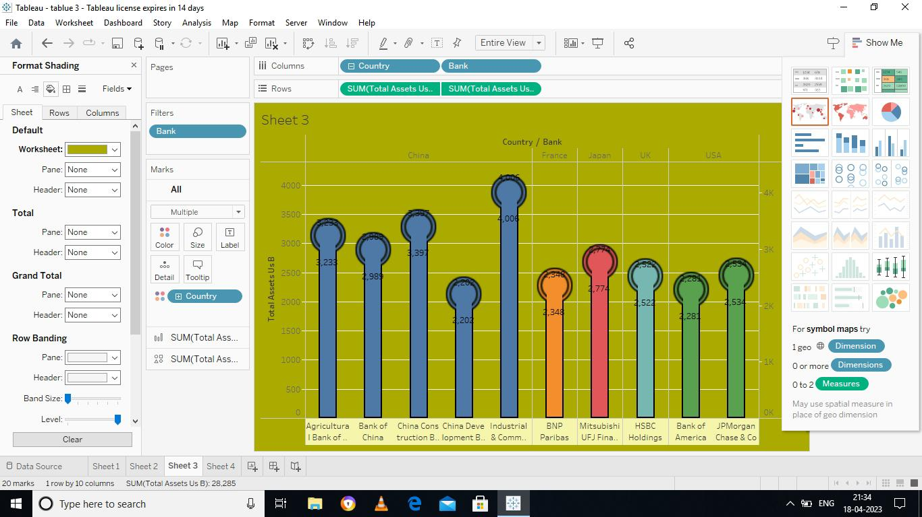

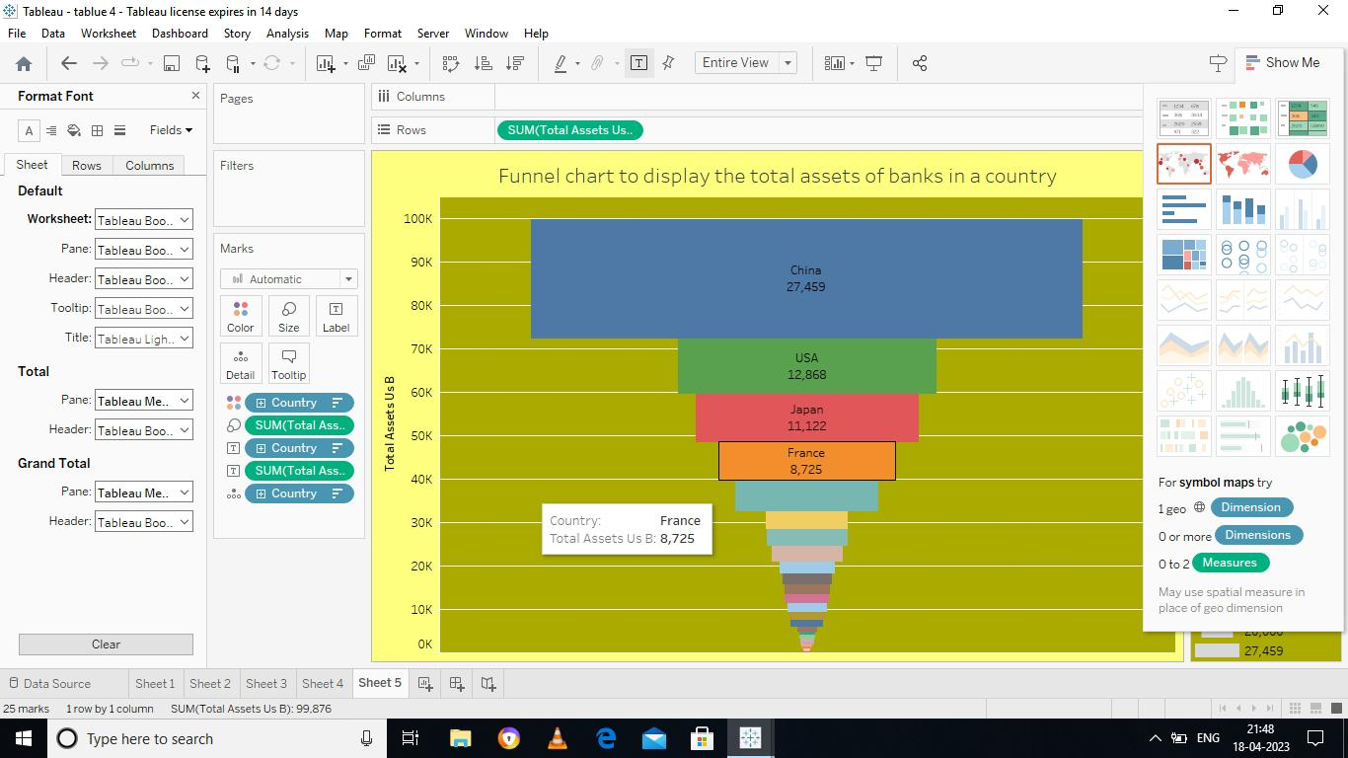

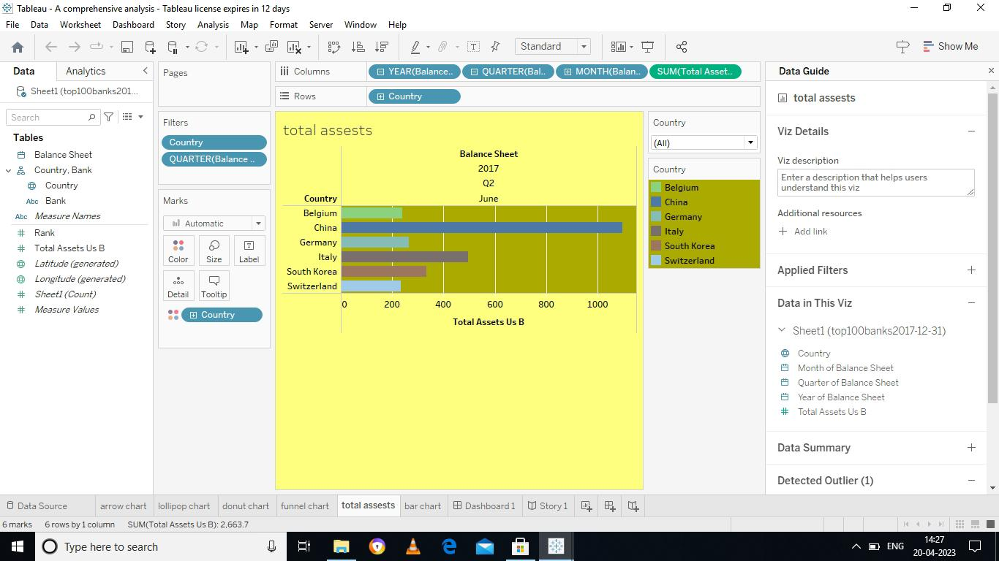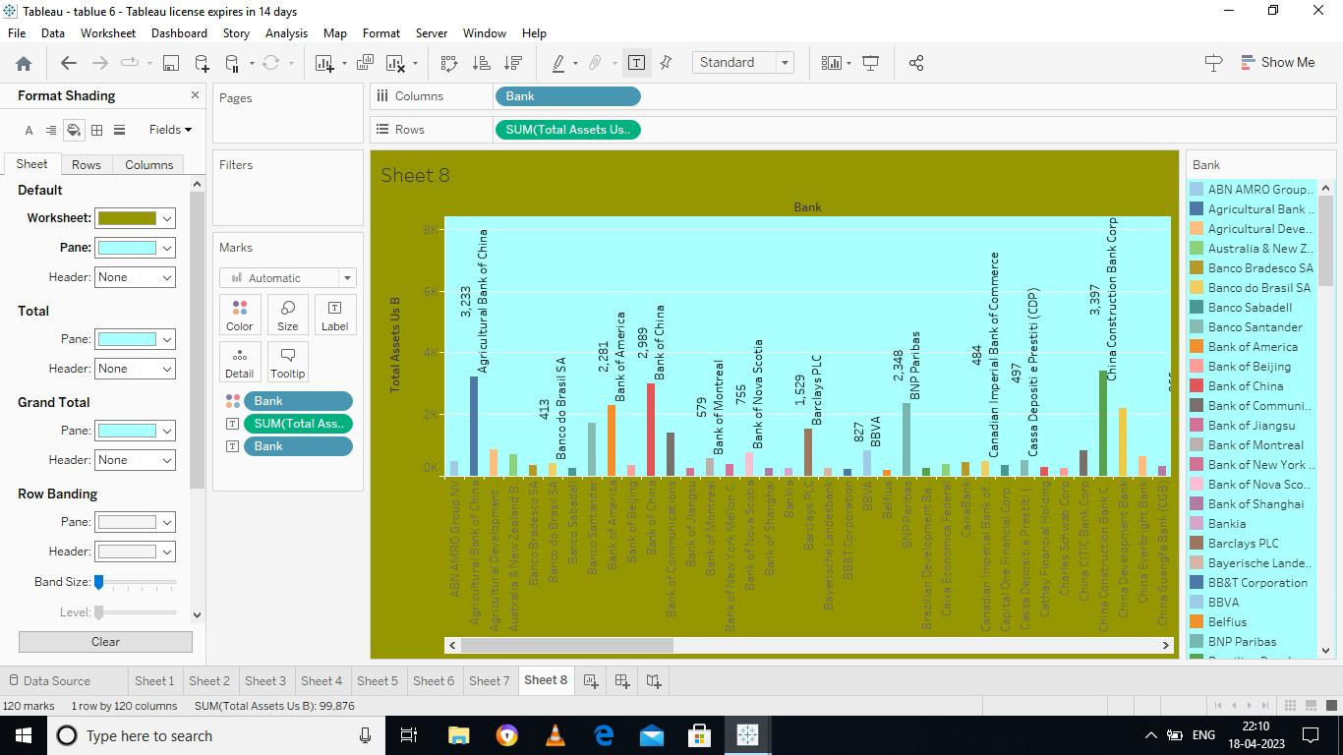



**ADVANTAGE**

* Internal and external stakeholders
* Business health grow
* Assessing the profitability
* Evaluation of past performance
* Prediction of future performance

**DISADVANTAGE**

* Problem in comparability
* Reliability of figures
* Change in Accounting method
* Change of Business condition
* Based of past data

**APPLICATIONS**:

Financial analysis is used to evaluate economic trends, set financial policy, build long-term plans for business activity, and identify projects or companies for investment. This is done through the synthesis of financial numbers and data.

**FUTURE SCOPE**

Use of Blockchain technology: Blockchain technology has the potential to streamline and simplify financial transactions, which could have a significant impact on financial performance analysis.

Integration of AI and machine learning: With advancements in technology, there is an opportunity to integrate AI and machine learning algorithms into the financial analysis process

Focus on environmental, social and governance(ESG) factors: There is a growing focus on ESG factors in the financial industry, and this is likely to continue in the future.

**CONCLUSION**:

Analysis of financial statements is extremely important for every business to grow and increase their revenue. It should not be compromised since it increases the efficiency of business operations. Better processes and expert analysts can help in the detailed analysis process.